Discussion
Asthma is a chronic disease that adversely affects the overall quality of life for children during their formative years, and their exposure to indoor air pollutants may exacerbate their asthma. However, effective strategies are available to reduce exposure and prevent asthma symptoms [29]. In this pilot intervention study, the effectiveness of the combined intervention with asthma education and air purifier was investigated using a crossover design for 15 days. Asthma education was provided at baseline and a low-cost affordable air purifier was operated for a week after a week of air monitor optimization. Our study showed a statistically significant decrease in the mean PM2.5 concentration by 1.91 μg/m3 and the PedsQL score by 6.08 points, indicating the improvement of IAQ and quality of life in children with asthma. Previous studies have shown that families educated with a curriculum based on Asthma and Healthy Homes had improved asthma symptoms and increased knowledge of children and their parents as well as the quality of life for the family [14, 15, 28]. The curriculum is focused on a holistic educational intervention including the signs and symptoms of asthma, the disease management, common triggers of asthma, adequate use of asthma medications, emergency action plans like an asthma attack, and components of an asthma action plan [15]. It also included the Seven Principles of Healthy Homes, developed by the National Healthy Homes Training Center and Network. The educational components focused on how to keep a home dry, clean, ventilated, pest-free, safe, contaminant-free, improving the indoor environment, and decreasing hazardous exposures within the home [15]. In contrast to most previous studies that applied a single type of intervention, this study implemented a combined household intervention that included air purification and asthma education and evaluated changes in asthma for children in this study. We found that most of the households showed the PM2.5 level decreased after the combined intervention, indicating the consistent results as previous studies. Specifically, the frequency of detecting PM2.5 levels below the World Health Organization (WHO) annual target of 10 μg/m3 was increased, and subsequent improvements in children’s asthma control and management were demonstrated by four different surveys, regardless of the difference Journal of Environmental and Public Health.

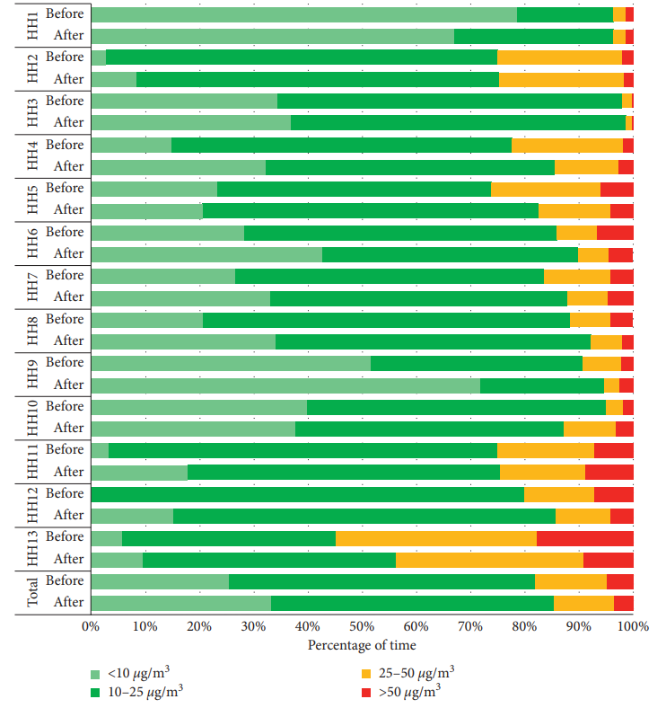

in some household characteristics [38]. 'is result is consistent with the findings of other intervention studies using HEPA filtration. A study found that indoor PM2.5 level was reduced from 7.6 μg/m3 to 3.4 μg/m3 after the HEPA intervention [39], and another study also reported a significant reduction in PM2.5 level from 8.0 μg/m3 to 4.8 μg/m3 with the use of HEPA [40]. As awareness of the impact of indoor air pollution on health increases, new monitoring technologies are developed to monitor the quality of indoor air. While international standards such as ISO 16000-1 [41] and the EPA standard protocol for characterizing IAQ [42] establish routines for IAQ monitoring, the desire to simultaneously monitor different rooms, initial investment, and need for trained personnel to handle and analyze the data pose clear challenges. Additionally, in alignment with the aim of this work, low-cost monitors were considered a suitable option. However, their use may have inconveniences, i.e., additional data quality protocols and the risk of data loss if their connection is lost [43]. Another critical consideration is the use of a variety of algorithms used by different manufacturers to convert the sensor output into a concentration value for each pollutant [44].There is, however, an important limitation of the Foobot. It is not suitable for outdoor use, limiting the collection of outdoor data and the limited air pollutants it measures. Despite the low-cost monitors’ limitations, there are also some benefits: advanced software processing of air quality data, compact size, continuous measurements, potential of customization, deployment, high scalability, low maintenance, low-cost, lowpower consumption, possible auto-calibration, and quick responses [25]. Our study has several limitations. Firstly, the total study period, including pre- and postintervention periods, was 15 days so that it might be a shorter time to see substantial changes in indoor air condition and participants’ health outcomes when compared with other similar studies that had at least 4 weeks [40, 45]. However, we observed a 12% significant reduction in the mean PM2.5 level and some positive outcomes in children with asthma, providing a promising basis for future studies. Second, some of the air quality data collected from air monitors were lost due to poor Internet connection in the study field even though a strong data collection and management plan was used in this study. Since some houses were located in remote sites, where the Internet connection was not stable, we could not store the data on our servers and the chosen instrument did not have internal data storage. However, the PM2.5 levels were measured every five minutes for two weeks, and enough number of measurements was obtained to compare air quality before and after the intervention except three households that were excluded. 'ird, we did not use a traditional air monitoring approach to collect samples and analyze later with highly accurate and precise analytical instruments, such as gravimetric sensor, because they require high cost and skills to operate and maintain, leading to the relatively short duration of measurements [28, 46]. Instead, we opted for longer monitoring periods using low-cost and direct-reading consumer monitor (Foobot), which can be accessible to the families in low socioeconomic status and viable for largescale health programs. 'is instrument is widely used to monitor indoor air quality, and its performance and quality have been demonstrated in the previous studies [28, 47, 48]. Fourth, due to the small sample size, we could not use the statistical model to adjust the characteristics of socioeconomic status, which may affect asthma severity. Given that similar studies included more than 40 participants [39, 40, 45], the future study should have more sample sizes to obtain better results by conducting a statistical analysis. However, the socioeconomic status of participating families in this study is homogeneous as low-education and lowincome Hispanic population supported by public health insurance aid was recruited. Lastly, like any other similar study, participants’ engagement was difficult to retain. We had difficulties in setting up appointments with participating households, including last-minute cancellations, and using the air purifier. Although air purifiers were intended to stay turned on during the entire study period, some households turned them off when the child was not at home to save energy. Despite some limitations, there are several strengths to this study. First, we examined the effect of the combined household intervention, including the use of affordable air purifier and asthma education, on health outcomes of children with asthma in families with low socioeconomic status, demonstrating a more effective way to improve pediatric asthma population’s health outcomes and reduce health disparities in low-income communities. Second, validated air monitors were installed in three different places of each household to measure overall air condition in households more correctly and eliminate any potential bias caused by the instruments. 'ird, we used multiple survey tools to measure various health outcomes of children comprehensively before and after the intervention. Finally, our study proposed a potential intervention method to reduce the risk of other respiratory diseases, lung cancer, and cardiovascular diseases related to PM2.5 exposure [49].

