2.2. Interventions.
The CHWs educated children and their parents after conducting surveys for health outcomes when they visited each household on the first visit. A holistic home-based educational intervention was provided to participants focusing on asthma control management and healthy home environments. 'is intervention aims to educate families on how to manage and control their child’s asthma more effectively and improve their home environments, including management of the home environment journal of Environmental and Public Health
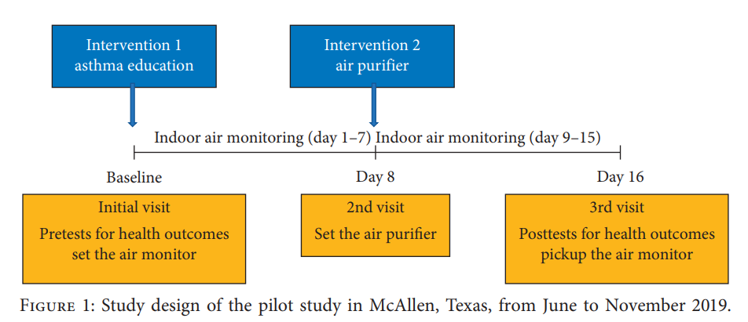

and asthma symptoms, identification of common triggers, and adequate medication use and adherence. 'e curriculum details are explained elsewhere [15, 27]. On the second visit a week after the initial visit, the CHW installed the Levoit® Air Purifier (Model# LV-H132) in the child’s bedroom where children spent the longest time in the house [28]. 'is air purifier has an advanced 3-stage filtration system including the prefilter, true HEPA filter, and highefficiency activated carbon filter to capture allergens, pet hair, dander, smoke, mold, odor, and large dust particles, in addition to removing 99.97% of airborne contaminants as small as 0.3 microns as indicated by the manufacturer.

