2.3. Indoor Air Quality Assessment.
Previous studies evaluated the Foobot monitor’s performance and accuracy, proving that it is a reliable tool to measure relative levels of indoor pollution [28, 29]. 'e Foobot was calibrated and tested in our offices in McAllen for two months before the study. 'e calibration equations were produced through the regression of a test conducted prior to this study. 'ey were developed after testing and comparing the results from 10 Foobots to one kit of standard instruments (GrayWolf PC3016A and IQ-410). 'e equation PM2.5 is as follows
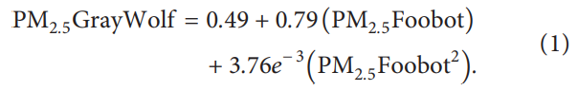

Testing of the air temperature and relative humidity sensors indicated that they are accurate, as the temperature sensor demonstrated a mean difference of −0.24°C compared to the testing instruments. Similarly, relative humidity showed a mean difference of 0.52% RH. To reduce the bias of low-cost monitors, three Foobots were used in each room, respectively, and calibration equations and data quality/ corroboration, by comparison, were followed as suggested in previous studies [30,31]. 'e ASTM D7297-14 standard was followed to measure the physical IAQ measurements [32]. Although the IAQ is far more complex than PM2.5, there is more evidence about its effects to respiratory diseases, including asthma especially in children [33–35]. A series of three Foobot monitors (air temperature [−40–125°C; ±0.4° C], relative humidity [0–100% RH; ±4% RH], and PM2.5 [0–1,300 μg/m3 ; ±4 μg/m3 ]) were installed at the bedroom, kitchen, and living room in each household. During five-minute intervals, the Foobot air monitors collected data about air quality parameters over two weeks in each household. In particular, PM2.5 was measured continuously throughout the study period and was estimated as μg/m3 [36]. Data was saved automatically in secured online storage and stored in an encrypted computer safely.

