Indoor air quality monitoring (IAQM) systems
Currently, the increasing health issues due to IAP are an essential matter of discussion for researchers worldwide. Some professionals utilized advanced sensor networks and communication technologies to propose IAQ monitoring systems for the enhanced living environment. As researchers are actively working in this field to improve building health, it is difficult to review all existing and proposed IAQ monitoring systems in this paper. Nonetheless, this section includes studies based on the most prominent IAP parameters. As automatic alert systems are need of the hour in our busy schedules, we have preferably picked monitoring systems that propose online access to recorded environmental factors or generate SMS based alerts. Although several techniques have been invented for real-time monitoring, the preference to be reviewed was given to Wireless Sensor Network (WSN) and Internet of Things (IoT) based models due to their rising scope in the Industry 4.0 revolution. Alhmiedat and Samara [32] developed a low-cost ZigBee sensor network architecture to monitor IAQ in realtime. It is possible to install four sensor nodes in the indoor environment and collect data for more than four weeks. The environmental data were further transferred for analysis via a ZigBee communication protocol. Authors of this paper analyzed CO2, benzene, NOx, and ammonia for IAQ assessment at the time of cooking in the kitchen, while other sensors collected desired input from the bedroom, living room and office area. It provides real-time monitoring of all factors contributing to indoor air; however, few developments to this system can be still made by reducing power consumption and improving the accuracy of monitored parameters. Wu et al. [33] worked on mobile microscopy and machine learning methods to perform accurate quantification and impact analysis of PM. The authors demonstrated a cost-effective and portable PM imaging, quantification and sizing model named C-Air, and the results were displayed on a mobile-based app. A remote server was used for automated processing of essential digital holographic microscope images that ensues accurate PM measurements. This system was capable of providing valuable statistics about density distribution and particle size with the sizing accuracy of approximately 93%. C-Air can be customized to detect specific air particles such as mold an

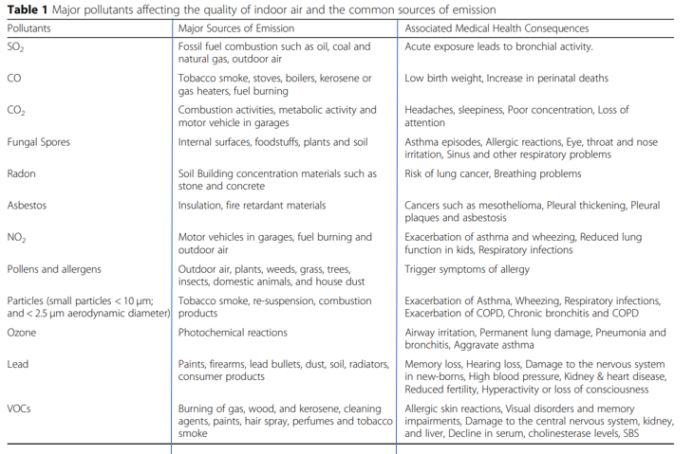
pollens. The performance of C-Air was tested for indoor as well as outdoor air environments. Zampolli et al. [34] developed a low-cost model with an electronic nose based solid-state sensor array for monitoring IAQ. By using a combination of advanced pattern recognition techniques and optimized gas sensor array, researchers targeted the quantification of NOx, CO, along with VOCs and relative humidity (RH). The performance of the electronic nose was analyzed in real operating conditions where NO2 concentrations at 20 ppb and CO at 5 ppm were monitored continuously for at least 45 d. This approach helped to identify the presence of individual pollutants along with the mixture of different contaminants in the test environment. This system was found feasible enough to detect NO2 and CO levels in indoor air, and these results were further used to manage the appropriate usage of heating, ventilation, and air conditioning (HVAC) systems in the indoor environment without disturbing the air quality. Kim et al. [35] focused on seven gases (CO2, VOCs, SO2, NOx, CO, PM, and ozone) to test IAQ in real-time. The experiments were conducted in three different settings: big church, medium size classroom, and small size living room to test the impact of different factors on IAQ. Researchers concluded that so many factors contribute to altering the quality of indoor air. Some of these are wind, location, airflow, the density of people and room size. However, it was found that gas sensors consume lots of power, so it is important to apply critical thinking for the selection of appropriate sensor nodes. Future researchers are also advised to work on environmental settings and sensor characteristics to ensure reliable calibration of the system to obtain accurate results. Yu and Lin [36] constructed an intelligent wireless sensing and control system to deal with health issues caused by IAP. The system is made up of three different parts: 1) Data acquisition that helps in obtaining values about environmental indicators such as CO2 concentration, RH, and temperature through polling mechanism; 2) Data analysis, responsible for collecting data and interfacing with the AutoRegressive Integrated Moving Average (ARIMA) prediction model to analyze air quality trends in the premises; and 3) Data feedback to trigger necessary actions based on fuzzy results. It may send a warning message or may control the speed of the fan automatically. Each sensor node in this hardware architecture is powered by the IEEE1451.4 standard, and the
communication channel is established by ZigBee technology. The software architecture is precisely separated into three different sections where 1) Data monitoring agent creates a bridge between software and hardware, Home Page (PHP). The prime goal to design this system was to help users get instant updates about exposure risks in the living environment. Benammar et al. [44] designed an end to end IAQM system using WSN technology. It was focused around the measurement of RH, ambient temperature, Cl2, O3, NO2, SO2, CO, and CO2. The sensor nodes were made to communicate to the gateway via XBee PRO radio modules. The sensor nodes in this study include a set of calibrated sensor units, a data storage unit named Waspmote, and sensor interface board known as Gas Pro sensor board. The prime role of the gateway in this study was to process the IAQ data collected from target sites and perform reliable dissemination via a web server. This system was adapted to open source IoT web server platform, named Emoncms to ensure long-term storage as well as live monitoring of IAQM data. Seamless integration of smart mobile standards, WSN, and many other sensing technologies is performed to design the ultimate scalable smart system to monitor IAP. In order to meet the power requirements of the system, authors also designed separate battery units for the sensor network. Saad et al. [45] created a system to monitor various environmental parameters that are directly related to air quality. They focused on RH, temperature, PM, and gaseous pollutants that have a direct impact on human health. A WSN was used to measure data from the target location, and it was transferred to the base station via the WSN node. A self-developed server program on the computer system used to access and process this data to analyze IAQ on a real-time basis. Tiele et al. [46] focused on the design and development of a portable and low-cost indoor environment monitoring system. This study was performed on a few essential parameters of indoor air such as sound levels, illuminance, CO, CO2, VOCs, PM10, PM2.5, RH, and temperature. The experiments were conducted in both indoor work environments and outdoors. The authors defined an Indoor Environment Quality (IEQ) index to estimate the overall percentage of IEQ. Moreno-Rangel et al. [47] presented a study to assess usability, accuracy, and the precision of low-cost IAQ monitor within a residential building. After analyzing the cost and complexity related issues associated with existing scientific solutions for IAQ monitoring, the authors proposed a reliable and low-cost system for households. They focused on a few essential parameters, such as PM2.5, CO2, VOCs, RH, and temperature. All sensors were calibrated before installation to ensure an adequate measurement. The collected data was analyzed using FOOBOT monitors based on the percentage of time the pollutant levels crossed the threshold levels set by World Health Organization. In order to enhance the accuracy of the measurement, authors in this study used IBM SPSS Statistics to perform statistical analysis. Idrees et al. [48] closely observed the challenges associated with IAP and developed an Arduino based platform for real-time IAQ monitoring systems. They initiated steps toward the detailed investigation of factors such as computational complexity, infrastructure, issues, and procedures for efficient designing. The prototype for the proposed real-time IAQ monitoring system was designed using the IBM Watson IoT platform and Arduino board. The authors worked on eight parameters that have a considerable impact on human health in the building environment. The list includes RH, temperature, O3, SO2, NO2, CO, PM2.5, and PM10. The significant advantage of this system was its ability to reduce the computational burden of the sensing nodes by almost 70%, leading to longer battery life. In order to ensure higher accuracy for measurements, authors used standard calibration procedures on sensor networks, and a data transmission strategy was used to minimize the power consumption along with redundant network traffic. The three most essential layers of the proposed monitoring system were sensing layer, edge computing layer, and application layer. This model reported a reduction of 23% in the overall power consumption, and the performance was validated by setting the system in different environments. Sivasankari et al. [49] proposed an IoT based system to monitor IAQ, and the analysis was performed using a Raspberry Pi model. The parameters included in this study were RH, temperature, NO2, CO, and concentrations of smoke. The measurements were done using MQ series sensors, Mics 2714 NO2 sensor, LM-35, and DHT11 sensor. An analog to digital converter was also added to the system so that sensors can be directly interfaced with the Raspberry pi module via eight different channels. This system was used to generate an alarm for indicating a high concentration of emissions, such as a warning for the air pollution rate in the premises. Arroyo et al. [50] presented an air quality measurement system made of a distributed sensor network and cloud-based WSN system. Low power ZigBee motes were used for collecting field data, and an optimized cloud computing system was implemented for processing, monitoring, storing, and visualizing received data. This laboratory study was based on the measurement of VOCs, including xylene, ethylbenzene, toluene, and benzene. Multilayer perceptron, principle component analysis, support vector machine, and backpropagation learning algorithm were used at the data processing stage. This section summarizes the review of IAP monitoring systems that are proposed by early researchers from different countries in the past few years. The main idea is to discuss potential techniques, architectures, and configurations that are already used by researchers. Reliable and efficient monitoring systems can be used in urban as well as rural areas to monitor the IAP and its impact on residents. It is believed that instant alerts can guide people to make proper ventilation arrangements by opening windows or doors in the kitchen; such systems are more useful in homes having traditional cooking systems, and inadequate ventilation arrangements. The results and discussion section further provide a detailed analysis of these studies while covering the strengths, weaknesses of the existing IAQ monitoring systems along with future scopes to guide future researchers.

