Introduction
With the ongoing improvements in quality of life, breathing environment has become an essential area of concern for researchers in the twenty-first century. Many studies confirm that indoor air is more deadly then outdoor air [1]. Nowadays, 90% of the rural households in the most developing countries and around 50% of the world’s population make use of unprocessed biomass for open fires and poorly functioning cooking stoves indoors. These deficient methods of cooking are responsible for indoor air pollution (IAP) and poor health of women as well as young children who are often exposed to such a polluted environment [2]. Biomass and coal smoke carry a wide range of harmful pollutants such as Particulate Matter (PM), Nitrogen Dioxide (NO2), Carbon Monoxide (CO), Sulphur Oxides, polycyclic organic matter and formalde hyde [3, 4]. Constant exposure to IAP due to the combustion of solid fuels is the common cause of several harmful diseases in developing countries. The list includes chronic obstructive pulmonary disease (COPD), otitis media, acute respiratory infections, tuberculosis, asthma, lung cancer, cancer of larynx and nasopharynx, low birth rate, perinatal conditions and severe eye diseases that can even cause blindness [5, 6]. In the developed countries, the impact of modernization has brought a significant shift in indoor fire and heating systems from biomass fuels such as petroleum products and wood to electricity-based appliances. As per World Energy Outlook 2017 [7], even after several improvements in cooking measures, 1.3 billion people in developing Asia are expected to rely on biomass for cooking by the year 2030. As per current estimates, 2.8 million premature deaths are reported every year due to the use of coal and solid biomass for cooking [7]. The scenario becomes worse with the use of kerosene, candles and other harmful fuels for lighting [7]. Generally, the types of fuels being used for household needs can become cleaner and efficient only if people start moving up on the energy ladder. Note that, animal dung is the lowest level of this ladder, and the successive steps are built with crop residues, wood, charcoal, kerosene, gas, and electricity [8]. People throughout the world tend to move upward on this Ladder as their socio-economic conditions allow them to improve their lifestyle, but reports reveal that poverty is the principal obstacle in using advanced and cleaner fuels. The slower development cycle in many parts of the world shows that biomass fuels will be utilized by poor households for decades ahead [9]. If we look at the stats provided by The Energy Progress Report 2019 [10], the global access to clean cooking was 58% in the year 2014, and it reached only 59% in the year 2016. The average growth rate was only 0.5% annually; unfortunately, it has been declining since the year 2010. With this annual rate of progress, it is not possible to meet the 2030 target of accessing cleaner fuels on universal level. In order to achieve the set goals, the annual growth rate must accelerate from 0.5 to 3% for the period 2016 to 2030. However, with the present stats, the chances are that almost 2.3 billion people worldwide will not have direct access to clean cooking in 2030. It means the health impacts of IAP will also persist; especially in the areas with inadequate ventilation arrangements [10]. Ventilation plays an essential role in the measurement of indoor air quality (IAQ). In case if proper ventilation arrangement is missing in building structures, the IAQ decreases and buildings become unhealthy to live. Studies reveal that IAP is observed as one of the major causes of increasing health issues associated with poor ventilation. As per a study conducted in few remote villages of Palpa district located in the western part of Nepal, the percentage deficit in ventilation is 80% as compared to the minimal rate suggested by the American Society of Heating, Refrigeration and Air Conditioning Engineers [11]. Another study report that poorly ventilation kitchens in Nepal have 100 times higher concentration of total suspended particles in comparison to the standard prescribed limit and it is due to excessive smoke generation in the premises [12]. Parajuli et al. [11] also monitored the impact of traditional cooking systems and improved cooking systems in the village houses. The estimated reduction of CO concentration and PM2.5 concentration was 30 and 39% respectively, with the use of improved cooking systems as compared to traditional cooking systems. Generally, the occupational and educational stats along with housing conditions in urban areas are relatively better when compared to the rural areas. These conditions have a direct relationship with the choice of fuel for household needs and consequently have a significant impact on IAQ. Reports reveal that poor IAQ is the second major factor for the higher mortality rate in India. It causes around 1.3 million deaths per year in the country. It is observed that out of 70% of the rural population in India [13], almost 80% of the people rely on biomass fuel to fulfill their household requirements [14]. The estimated number of people using harmful fuels for cooking in India is highlighted in Fig. 1 [15]. It means that the largest population of the country lacks access to cleaner and efficient sources of fuel for cooking needs. Kerosene and biomass cooking fuels are also the principal causes of stillbirth in developing countries. Studies reveal that around 12% of stillbirths can be easily prevented by using cleaner cooking fuel for the household needs in India. Similar studies conducted in other developing countries such as Bangladesh, Nepal, Kenya, and Peru show that IAP is causing severe health hazards. Hence it has become necessary to address the challenges, especially for indoor cooking in the rural sectors. Lack of knowledge and understanding of the benefits of cleaner cooking solutions is the principal cause of adverse health consequences. It is essential to design some efficient and affordable household cooking solutions over traditional stoves, and it can be done only after studying behavioral patterns of the low-income population in the country. The economic enhancements contribute to reducing IAP caused by various biomass fuels. However, the modern lifestyle is also leading to poor indoor environmental quality. With the improvement in the standard of living, most people are using indoor heating and cooling systems instead of natural ventilation systems [4]. This scenario has increased the cases of Sick Building Syndrome (SBS) somewhere around 30 to 200% [16]. Studies reveal that factors affecting indoor environment include the rate of air exchange, humidity, temperature, ventilation, air movement, biological pollutants, particle pollutants, and gaseous pollutants [17]. Buildings currently constructed are more airtight and make use of advanced insulation materials that help to reduce the loss of energy. However, the air conditioning systems and the latest building envelope also cause a reduction in the circulation of fresh air. Meanwhile, the increasing consumption of chemical products and synthetic materials in indoor environments has increased the presence of several Volatile Organic Compounds (VOC). It is one of the principal causes of hypersensitivity [18]. So, it is fair to say that we are still not safe from hazards associated with IAP. To deal with the increased mortality and morbidity rate due to IAP, numerous researchers are developing indoor environmental quality monitoring systems. Most of the people spend 80 to 90% of their time indoors either at home or in the offices. Thus, it is necessary to take immediate steps to improve the quality of indoor air. The idea is to create some healthy solutions that can contribute to a comfortable living environment while reducing the chances of the occurrence of severe diseases. This paper puts some light in the direction of efforts made by early researchers to deal with the challenges associated with IAP. The remaining parts of this review paper are organized below in three different sections, where section of “Indoor .

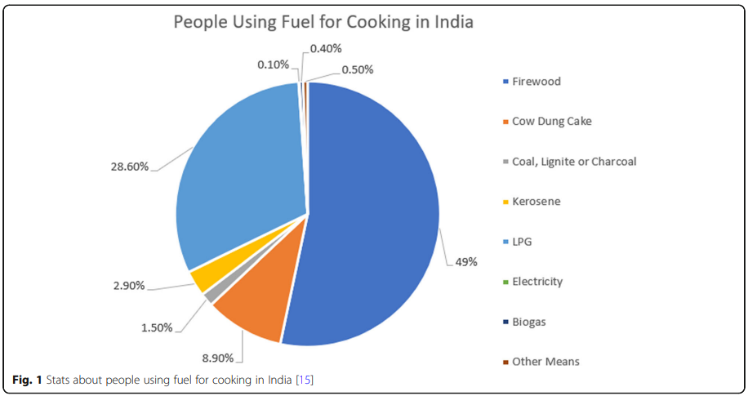

air quality and public health” describes the real-time cases of health impacts of IAP in developing countries along with the effect of various pollutants on public health. Section of “indoor air quality monitoring systems” presents an overview of some IAP monitoring systems developed in the past few years. The following section (Results/Discussion) provides a critical analysis of existing systems, along with the advantage and disadvantages of various technologies and sensor networks. Finally, the brief conclusion with future scopes of this study is given in the last section. This paper highlights the background of IAQ, primarily focusing on developing countries along with the potential ideas proposed for monitoring systems by different researchers. It is expected to guide future researchers to focus on new developments by considering the pros and cons of existing systems.

