Discussion and critical analysis
The primary requirement at present is to perform realtime monitoring of IAQ parameters and generate alerts to the building occupants to avoid hazardous conditions. The IoT approach has great potential in this direction to ensure lesser power consumption, negligible time delays, and has a better ability to interact with the physical world. One of the prime concerns in the development of IAQ systems is the higher cost and massive power consumption of sensor nodes. If we consider the real-time applications of IAQ systems, the sensor units are usually installed in an industrial environment, inside homes, offices, and outdoor areas as well. However, in all these cases, the design of the sensor unit demands more focus on size, design cost, power consumption, communication protocol, and performance dependence on temperature and humidity variations. Sensor calibration is currently the main
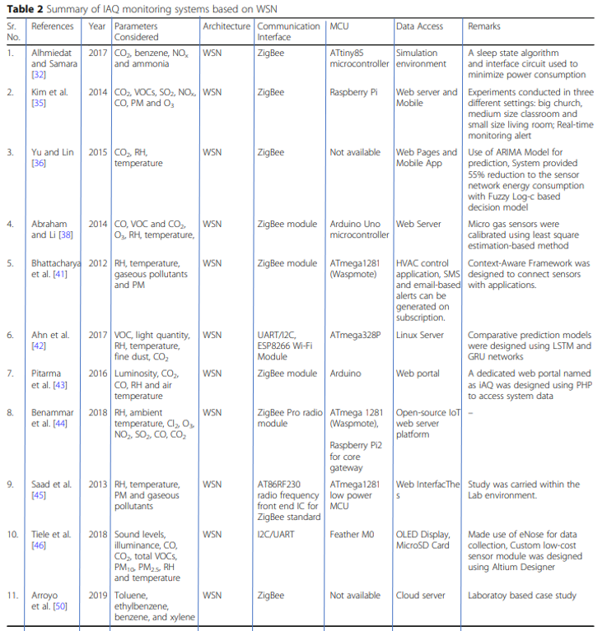

challenge in front of future researchers to ensure accurate real-time monitoring. Although Metal Oxide Semiconductor sensors are cheaper when compared to the optical and electromechanical sensors (some examples are TGS 2442 and TGS416), they work on the resistive heating; hence, consume loads of energy from limited battery unit of wireless motes. As a result, it reduces the overall lifetime of the network. A considerable solution to solve this problem is placing motes (a specific type of sensor node that can collect, process information and can communicate with other nodes in the network) in sleep mode when they are not working actively in the system. Some studies also reveal that a high-quality micro gas sensor can perform better in variable humidity and temperature conditions. One advanced solution to air quality monitoring is Mobile Sensing System for IAQ – personalized mobile sensing system that is gaining popularity due to the portable, energy-efficient and inexpensive design. Most of the researchers have used ZigBee to establish a communication network between sensor nodes and
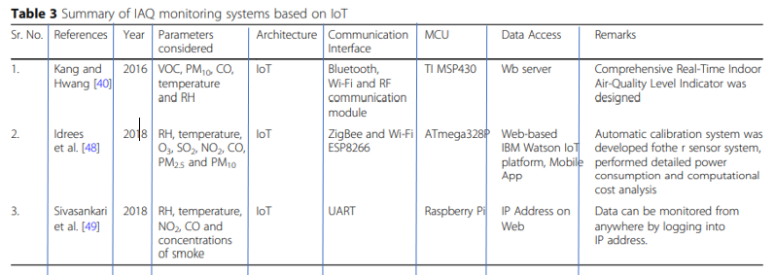

controller unit, but the prime disadvantages of ZigBee modules are short communication range and low network stability with high maintenance cost. The highly efficient IoT systems bring new scope to this field. By using IoT architecture and the Raspberry Pi microcontroller, which has in-built Wi-Fi communication features ensure fast data transfer. Note that the most used Arduino boards do not offer direct network connectivity. Therefore, users need to use additional modules for internet accessibility. One commonly used Wi-Fi module for Arduino boards is ESP8266 chip, but it needs an external converter for 5–3 logic shifting since most Arduino microcontrollers use 5 V operating voltage. Moreover, it leads to additional cost and energy consumption. Furthermore, Raspberry Pi 3 has more processing power than Arduino Uno as the clock speed for the former is 1.2 GHz, whereas later works on 16 MHz. Several methods for real-time IAQ monitoring are available in the literature. Furthermore, the presented methods provide practical solutions to improve occupational health and contribute to enhanced living environments considering numerous technical challenges. However, few improvements in the system performance are still required to ensure a reliable solution. By using an IAQ monitoring system, the manager can understand the IAQ behavior of the environment and plan interventions to avoid unhealthy situations. Therefore, the development of enhanced IAQ monitoring systems will address critical health challenges in today’s world. This section describes the weaknesses and strengths of the existing monitoring systems while describing the potential of available technologies and architectures. This in-depth review can guide new researchers to pick the most relevant topics for research in the future so that the quality of the living environment can be improved by inventing new methods and techniques

