Conclusions
In this review, the authors provide details about how various factors such as VOCs, PM10, PM2.5, CO, SO2.
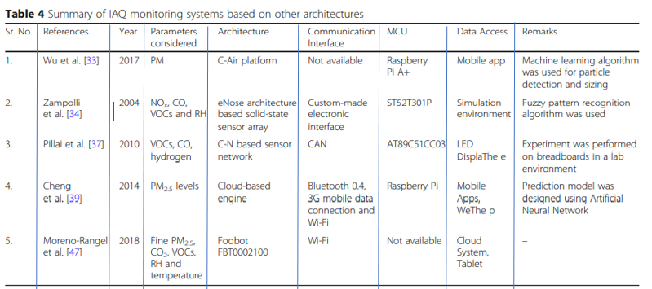

NO, O3, temperature, and RH affect IAQ. Furthermore, authors have highlighted the technical aspects of the studies performed by early researchers in this field. Trends reveal that most of the researchers till now have worked upon WSN and IoT architectures to study associated factors with IAQ and provide mobile computing software for data consulting. Instead of working within a controlled laboratory environment or on simulation systems, researchers need to implement real-time IAQ monitoring systems in real scenarios. The development of prediction systems is another primary concern for future studies because it is easier to control the adverse impact of indoor air pollutants when we are aware of future happenings. Deep learning models such as LSTM and GRU can be utilized to design the prediction systems, and the instant alerts about variation in indoor pollutant levels above the threshold limit must be sent via SMS or email to the smartphones. Note that, LSTM is the enhanced strategy to traditional Recurrent Neural Network, whereas GRU is the further extension to LSTM with forget and update gates. These models work with parameterized functions that have a direct impact on ideal parameters of the data; hence lead to better prediction. Mobile app-based systems analysis is also an essential part of the design. This field has considerable scope for development, and future researchers need to work on in-depth design solutions by combining IoT and deep learning models to come up with cost-effective, accurate, and reliable IAQ management systems. However, the research should not be limited to the industrial environment and cities. Only slightly suitable systems must be designed for the village areas where people suffer more due to their excessive exposure to solid fuels. The development of such systems can lead to an incredible contribution to the medical health department as well. The main areas of work for future researchers can be summarized as:
– Developing an IAQ monitoring system that can work efficiently in real-time conditions, instead of simulated or laboratory-based environments.
– Consider specific requirements of rural areas and design a cost-effective IAQ monitoring system to provide a safe solution for enhanced living environments.
– Work on IAQ prediction systems so that appropriate preventive measures can be followed on time.
– Designing a power-efficient and robust system for severe monitoring conditions in the urban as well as rural areas.
– Developing more efficient systems that can generate instant alerts to the users via email and SMS whenever IAP crosses certain threshold levels.
– Develop mobile app-based monitoring systems that can be operated by non-tech savvy people as well.
– Developing quick alert systems with possible preventive measures like switch on/off air conditioner, open/close windows, and check gas leakage to guide people towards healthy solutions with a variety of specific pollutants in the living environment.
In conclusion, the monitoring solutions/architectures proposed to address the IAQ should incorporate artificial intelligence to predict unhealthy situations for the enhanced living environment and occupational health.

